EX5.38
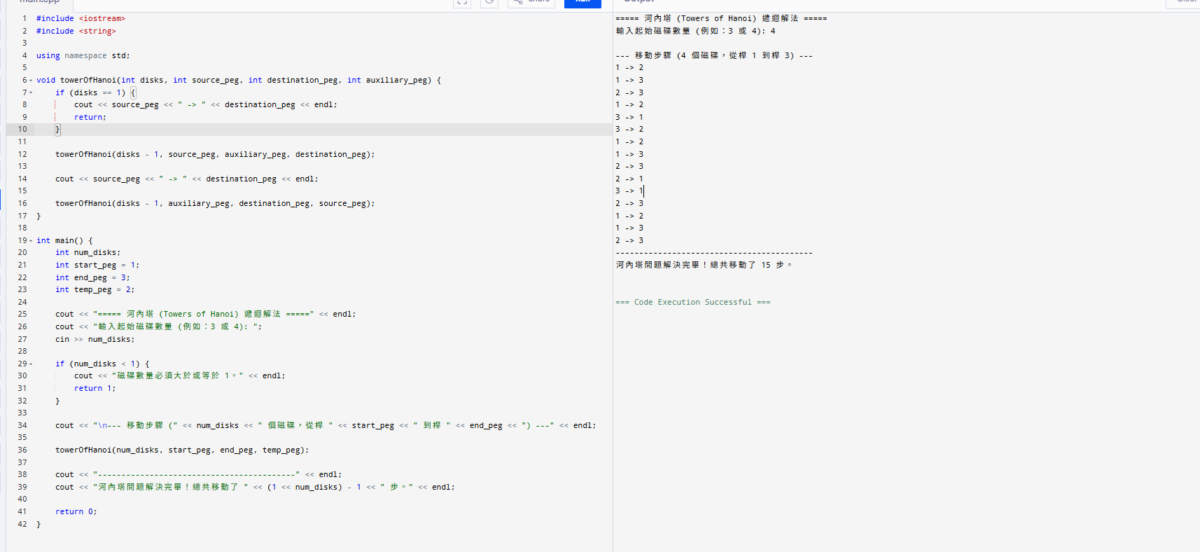
#include <iostream>
#include <string>

using namespace std;

void towerOfHanoi(int disks, int source_peg, int destination_peg, int auxiliary_peg) {
if (disks == 1) {
cout << source_peg << " -> " << destination_peg << endl;
return;
}

towerOfHanoi(disks - 1, source_peg, auxiliary_peg, destination_peg);

cout << source_peg << " -> " << destination_peg << endl;

towerOfHanoi(disks - 1, auxiliary_peg, destination_peg, source_peg);
}

int main() {
int num_disks;
int start_peg = 1;
int end_peg = 3;
int temp_peg = 2;

cout << "===== 河內塔 (Towers of Hanoi) 遞迴解法 =====" << endl;
cout << "輸入起始磁碟數量 (例如：3 或 4): ";
cin >> num_disks;

if (num_disks < 1) {
cout << "磁碟數量必須大於或等於 1。" << endl;
return 1;
}

cout << "\n--- 移動步驟 (" << num_disks << " 個磁碟，從桿 " << start_peg << " 到桿 " << end_peg << ") ---" << endl;

towerOfHanoi(num_disks, start_peg, end_peg, temp_peg);

cout << "------------------------------------------" << endl;
cout << "河內塔問題解決完畢！總共移動了 " << (1 << num_disks) - 1 << " 步。" << endl;

return 0;
}

